
“… an honorable story, a tribute to vets
that’s simply but beautifully told.”
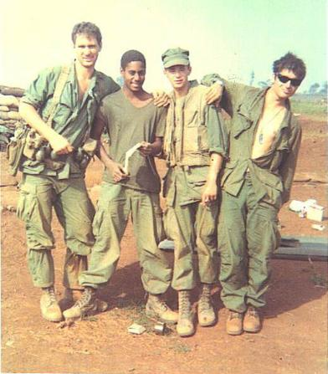
Chris Jones, Chicago Tribune
Place of Angels
A Play By Bob Adams,
Vietnam Veteran and MSHV Co-Founder
A Special Presentation to Benefit
The Midwest Shelter For Homeless Veterans
7 p.m., Monday, March 30, 2009
College of DuPage McAninch Arts Center
Tickets $50 • 630-942-4000 • www.atthemac.org

